**DAILY ONLINE ACTIVITIES SUMMARY**

|  |  |  |  |  |  |  |  |  |
| --- | --- | --- | --- | --- | --- | --- | --- | --- |
| **Date:** | **03-07-2020** | | | | | **Name:** | **Deril Quadras** | |
| **Sem & Sec** | **8 A** | | | | | **USN:** | **4AL16CS031** | |
| **Online Test Summary** | | | | | | | | |
| **Subject** | | **-** | | | | | | |
| **Max. Marks** | | **-** | | **Score** | | | **-** | |
| **Certification Course Summary** | | | | | | | | |
| **Course** | **AWS Compute Service Overview.** | | | | | | | |
| **Certificate Provider** | | | **AWS** | | **Duration** | | | **30 mins** |
| **Coding Challenges** | | | | | | | | |
| **Problem Statement:**   1. **Write a C Program to find Sum of diagonal of matrix** | | | | | | | | |
| **Status: Solved** | | | | | | | | |
| **Uploaded the report in Github** | | | | | **Yes** | | | |
| **If yes Repository name** | | | | | **Derilquadras/online_c_coding_repository** | | | |
| **Uploaded the report in slack** | | | | | **Yes** | | | |

Online Test Details:

Not Conducted

Certification Course Details:

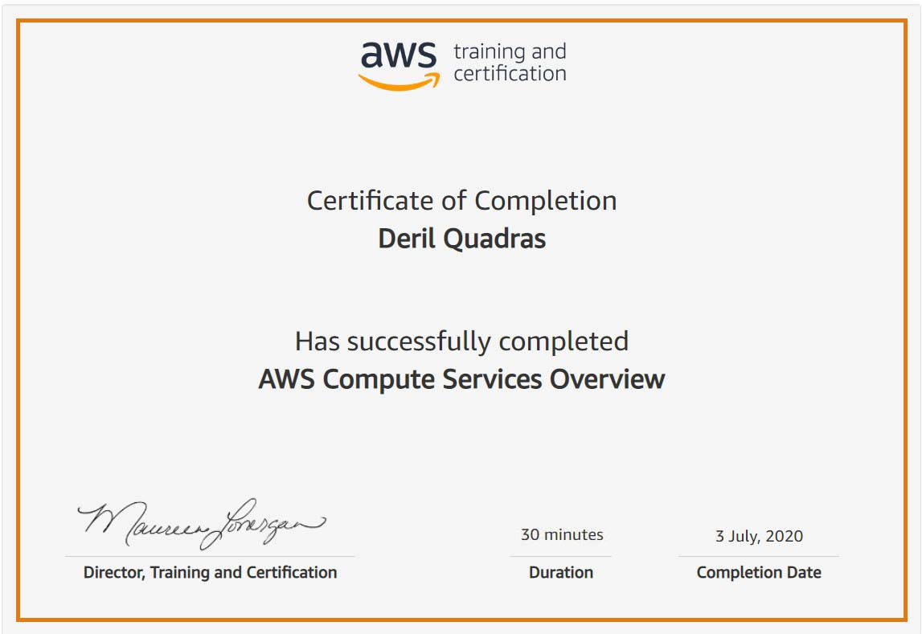

Coding Challenges Details:

**PROGRAM 1 .**

**// Sum of diagonal of matrix**

**#include <stdio.h>**

**int main ()**

**{**

**int a[10][10],i, j, m, n, b = 0, sum = 0;**

**printf("Enetr the order of the matix \n");**

**scanf("%d %d", &m, &n);**

**printf("%d %d\n",m,n);**

**if (m == n )**

**{**

**printf("Enter the co-efficients of the matrix\n");**

**for (i = 0; i < m; ++i)**

**{**

**for (j = 0; j < n; ++j)**

**{**

**scanf("%d\t", &a[i][j]);**

**printf("%d\t",a[i][j]);**

**}**

**printf("\n");**

**}**

**for (i = 0; i < m; ++i)**

**{**

**sum = sum + a[i][i];**

**b = b + a[i][m - i - 1];**

**}**

**printf("\nThe sum of the principle diagonal elements is = %d\n", sum);**

**printf("The sum of the secondary diagonal elements is = %d\n", b);**

**}**

**else**

**printf("The given order is not square matrix\n");**

**}**